**Naan Mudhalvan Project – digital marketing**

**Creating traffic on website:**

We used social media to advertise my website link with a poster on it

**Step 1:** open your browser and log into your account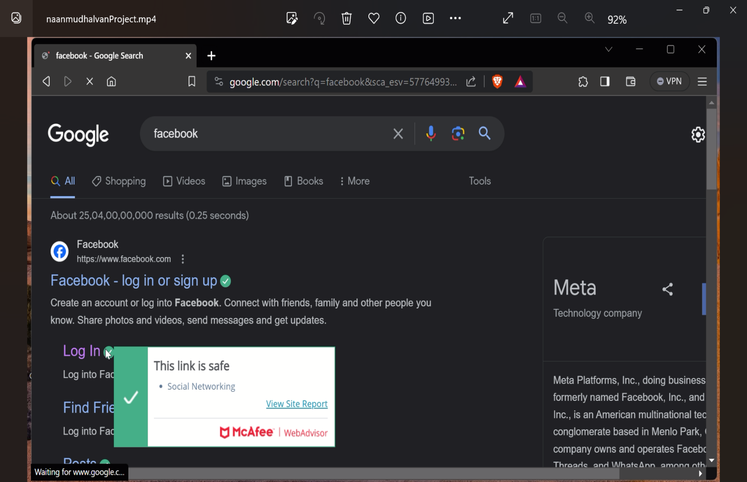

**Step 2 :create a post using your website posters**

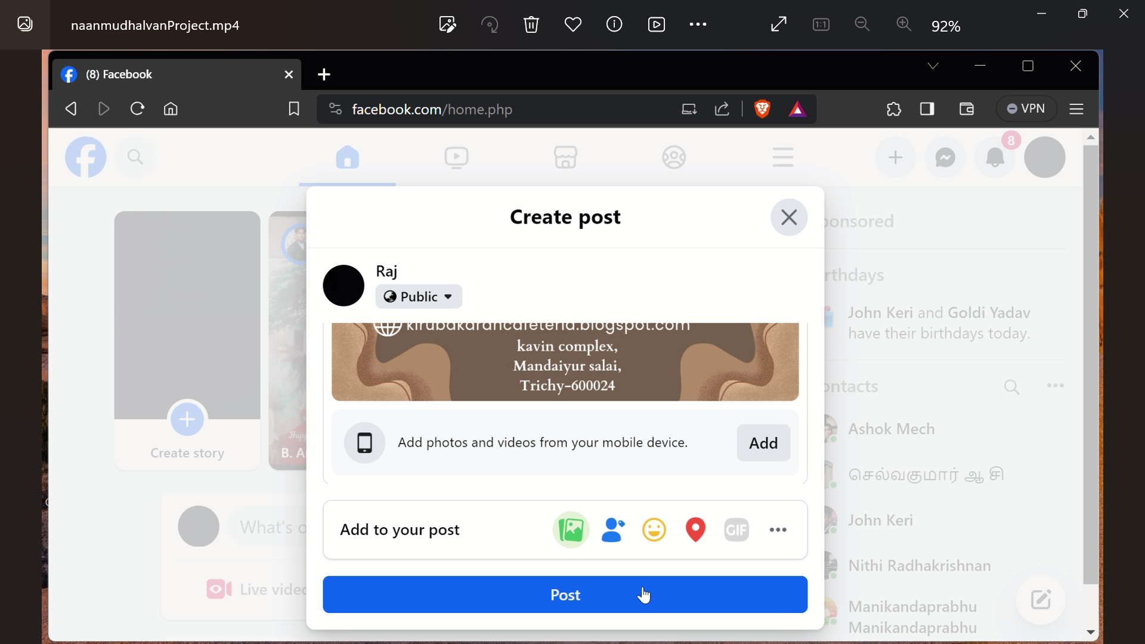

**Step 3: add a link to your website**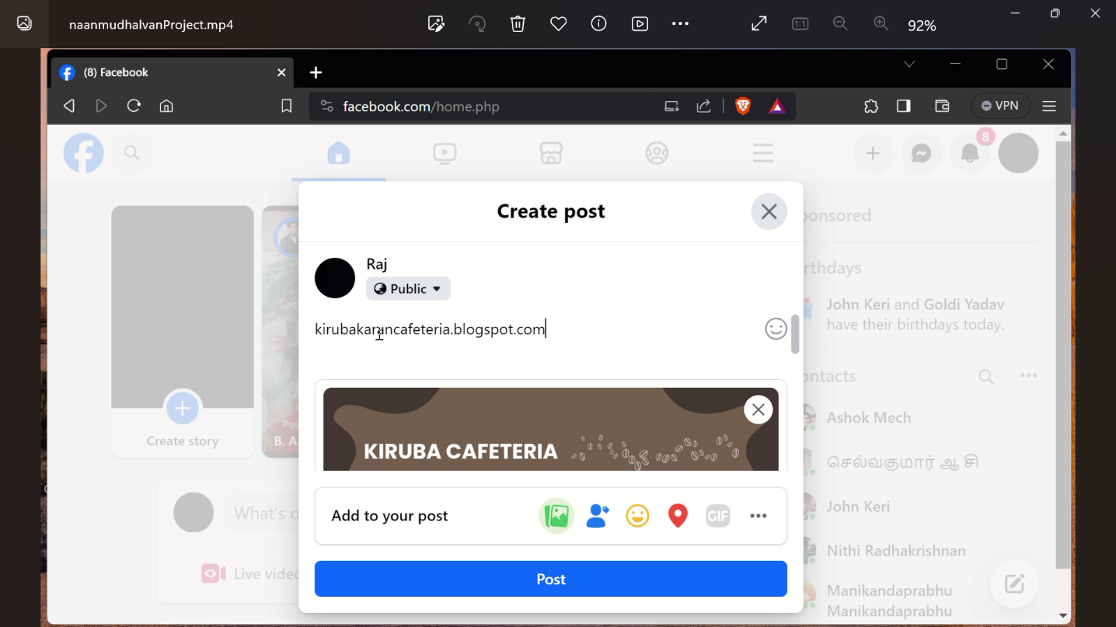

**Step 4 :post it on facebook**

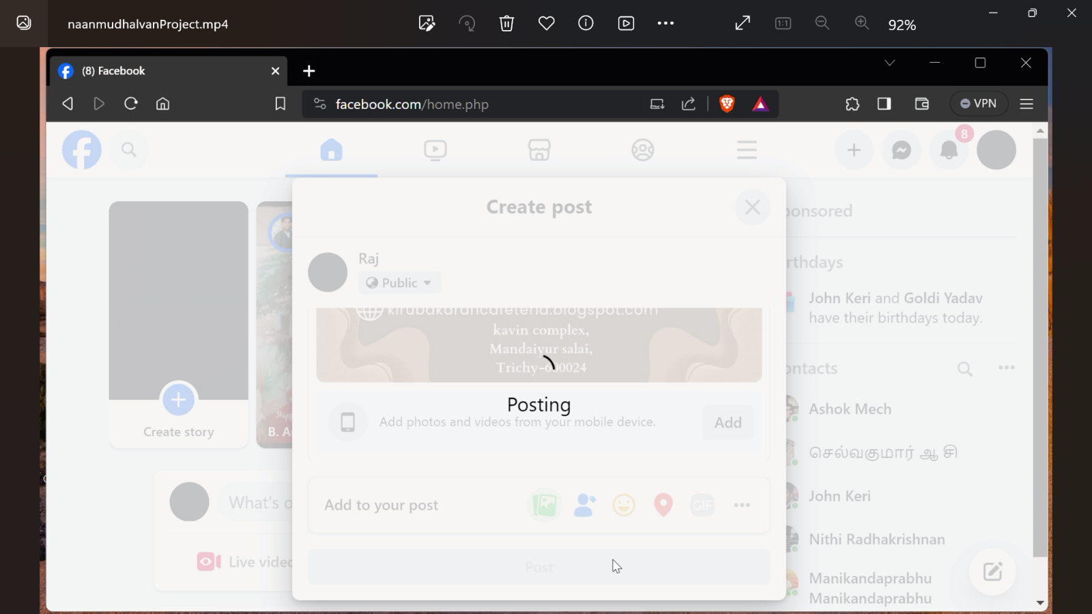

**Step 5: Share it public**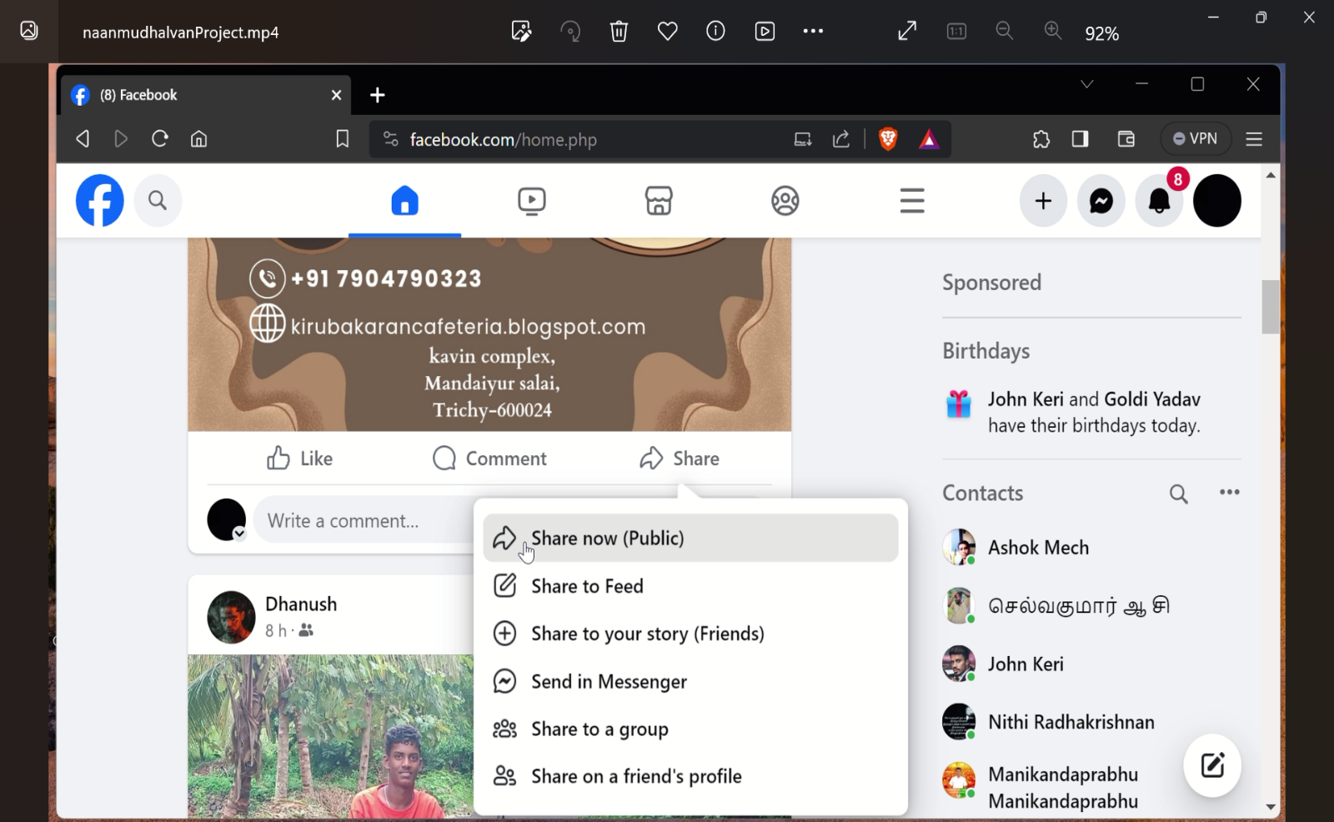

Views after posting after website:

